Record No: 0591
TENISON ALAN SOMERVILLE (TAS)
Of Naparihia Plantation, Trinidad; Dublin Castle and 3, Leinster Road, Rathmines, Dublin

7TH Son of Captain William Somerville (0563) and Elizabeth Bellingham (0564).

Birth: 16 Dec 1815 at Roseville,Loughbrickland, Co Down
Marriage: 6 Nov 1840 at St Mary’s Church, Dublin, Cecilia Eliza O’Connor (0592)
Daughter and co-heir of Daniel O’Connor by his wife Elizabeth nee
Ritchie
Death: 31 July 1895, 3, Leinster Rd. Dublin
Burial: 3 Aug 1895 Mt Jerome Cemetery, Dublin.

Source: Somerville Index

Notes:
SR3011: Baptised at Acton Church, Co Armagh, 31 Dec 1815
SR1801: Burial certificate
SR1802: Will drafted 11 Apr 1893, proved 20 Sept 1895
SR3012: Admitted to the Freedom of the City of Dublin 18 Jul 1883

TAS went to sea as a boy for 4 years. Subsequently, in 1832, he followed his elder brothers to Trinidad where he worked on the plantations. He returned to Dublin in 1840, after the death of his mother. He married on 6th November 1840 and then returned to Trinidad. He returned finally to Dublin in 1846 after his father’s death on 19thDecember 1844. He secured an appointment (possibly on the recommendation of John Woolsey of Castle Bellingham (SR3011K)) in the administrative section of the Royal Irish Constabulary in 1848, retiring in 1886.

From references to TAS in his father’s diary, from family correspondence and from what we know of him from other sources, TAS seems to have lead a sober and ordered life, unlike most of his brothers.

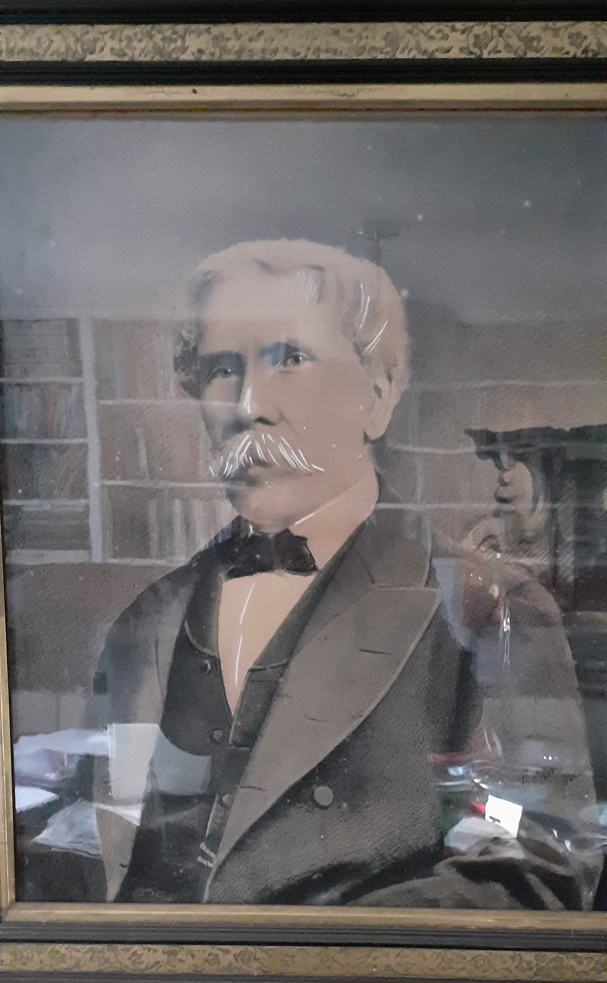
Tenison Alan Somerville (1815-1895)

